**Week 3**

JSP: Scriptlet, Expression & Standard Actions

Web Programming 2

Name: NURHASLINDA BINTI BAHARUDDIN

Matric #: S67383

Semester: 4

Lab: 4

Demonstrator: SIR ARIZAL

Lecturers

PUSAT PENGAJIAN INFORMATIK DAN MATEMATIK GUNAAN (PPIMG), UNIVERSITI MALAYSIA TERENGGANU (UMT)

# Revision History

|  |  |  |  |
| --- | --- | --- | --- |
| **Revision Date** | **Previous**  **Revision Date** | **Summary of Changes** | **Changes Marked** |
|  |  | First Issue | Mohamad Nor Hassan |
|  |  | Second Issue | Dr Rabiei Mamat Dr Faizah Aplop Dr Fouad  Ts Dr Rosmayati Mohemad  Fakhrul Adli Mohd Zaki |
| 21/02/2019 |  | Addition of Revision History,  Table of Contents, Formatting Cover Page | Fakhrul Adli Mohd Zaki |

Table of Contents

**Task 1**: Using JSP Scripting 4

**Task 2**: Using JSP (Scripting, Declaration and Expression) 7

**Task 3**: Using JSP Standard Action (Include and Param) 10

**Task 4**: Using JSP Standard Action (Forward) 14

**Task 5**: Use Java Scriptlet To Construct Business Logic 18

# Arahan:

Manual makmal ini adalah untuk kegunaan pelajar-pelajar Pusat Pengajian Informatik dan Matematik Gunaan (PPIMG), Universiti Malaysia Terengganu (UMT) sahaja. Tidak dibenarkan mencetak dan mengedar manual ini tanpa kebenaran rasmi daripada penulis.

Sila ikuti langkah demi langkah sebagaimana yang dinyatakan di dalam manual. Tandakan (√) setiap langkah yang telah selesai dibuat dan tulis kesimpulan bagi setiap aktiviti yang telah selesai dijalankan.

***Instruction:***

*This laboratory manual is for use by the students of the School of Informatics and Applied Mathematics (PPIMG), Universiti Malaysia Terengganu (UMT) only. It is not permissible to print and distribute this manual without the official authorisation of the author.*

*Please follow step by step as described in the manual. Tick (√) each step completed and write the conclusions for each completed activity.*

**Task 1: Using JSP Scripting**

**Objective :** JSP Scriptlet and JSP Expression in application.

# Problem Description

**:** Prepare a simple interface to perform the following payment process;

1. If Customer Type is Normal Customer (assign value as “1”) and Order Quantity > 100, customer entitle 10% discount.
2. If Customer Type is Privilege Customer (assign value as “2”) and Order Quantity > 100, customer entitle 25% discount.
3. Order Quantity must be in number.
4. Finally, display the results.

**Estimated time :** 40 minutes

1. Create Project *Lab3*.
2. Create a new HTML’s file.

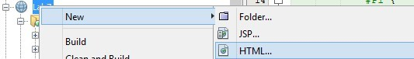

1. Type file name as *customer.*
2. Prepare the following Graphical User Interface (GUI).

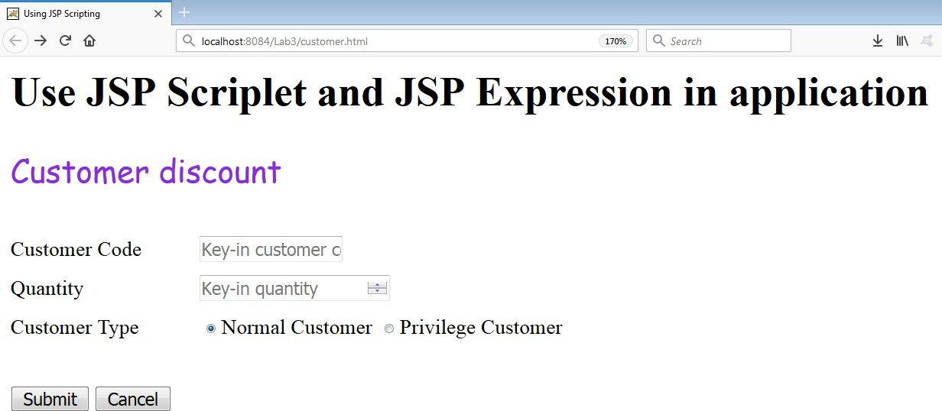

1. You must ensure the amount must be written as number.
2. The value for **Normal Customer** is “1” and **Privilege Customer** is “2”
3. Create a new file name known as *processCustomer.jsp*.
4. Define related variables and methods as below.

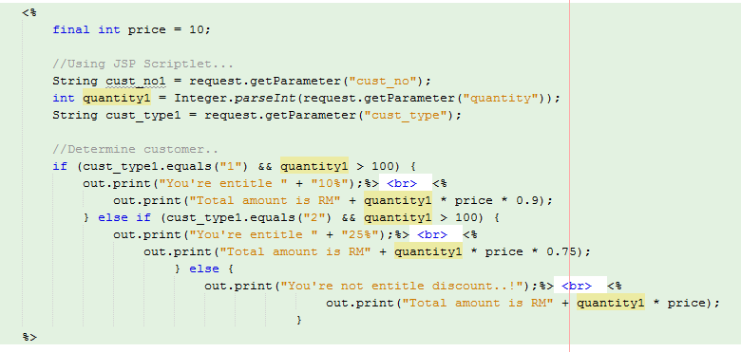

1. Compile *customer.html* and *processCustomer.jsp* file.
2. Run *customer.html.*
3. Enter information to the interface.
4. Output will appear in web browser.

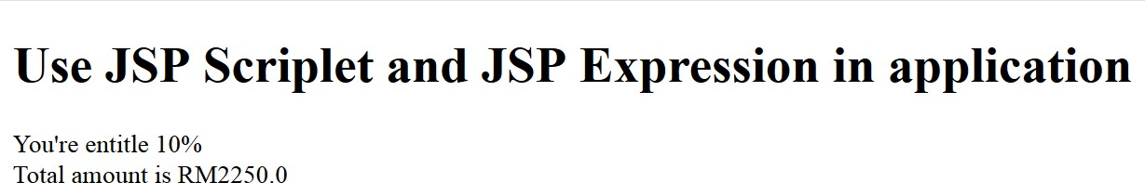

# Reflection

1. What you have learnt from this exercise?

How to use JSP Scriplet and JSP Expression in application.

1. Explain three (3) type of JSP scripting?

Expression, scriptlets and declarations.

THE CODE :

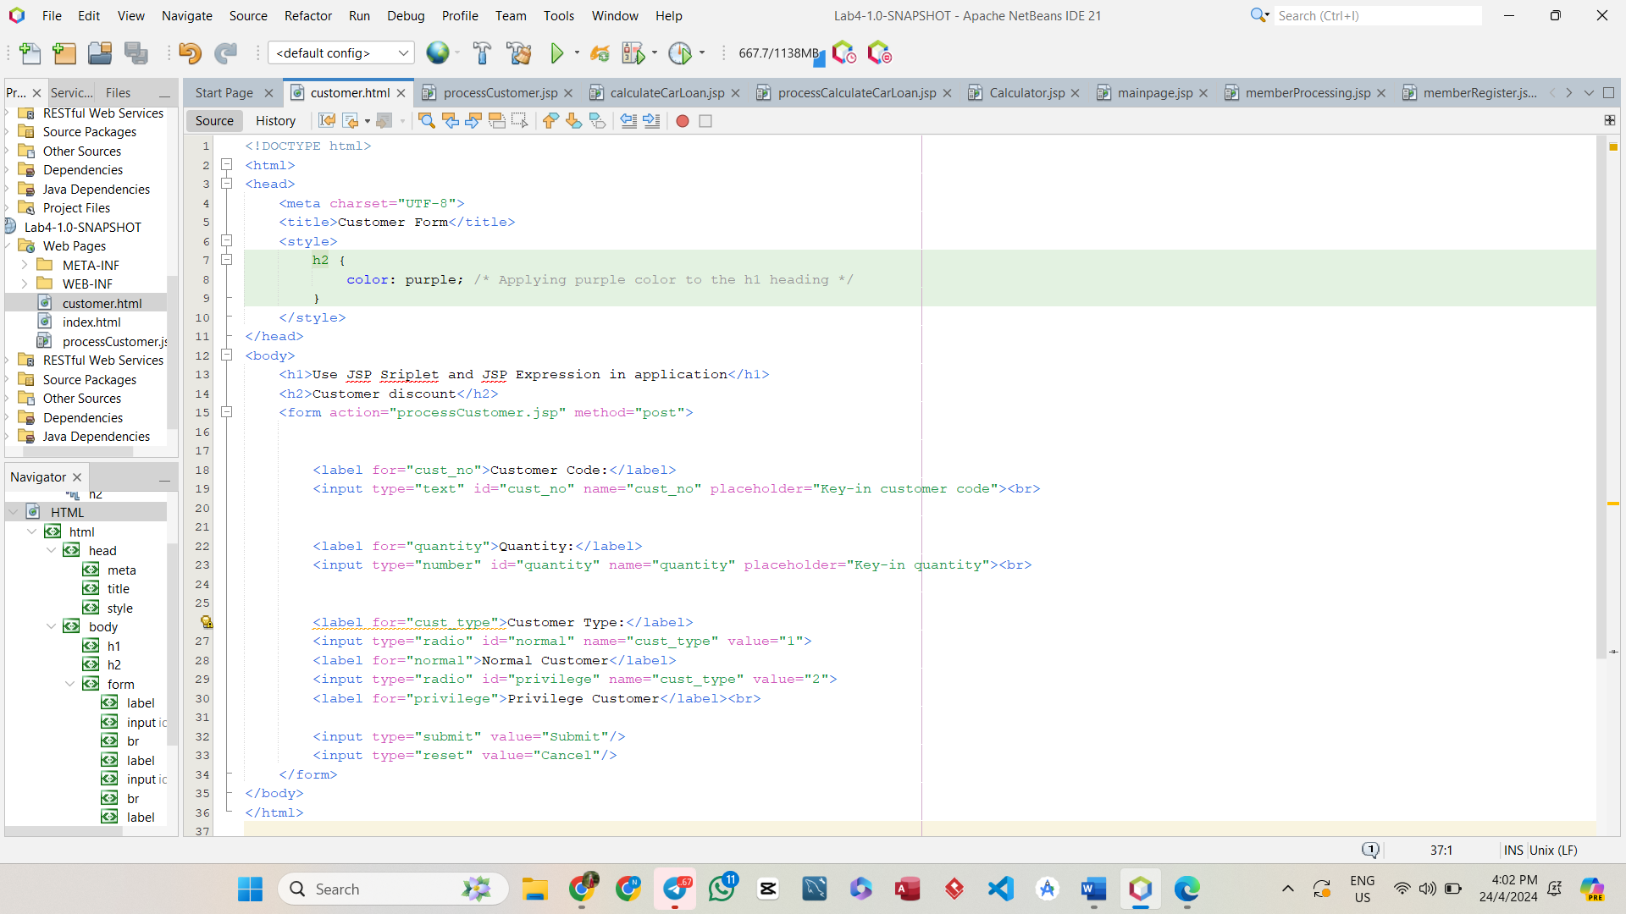

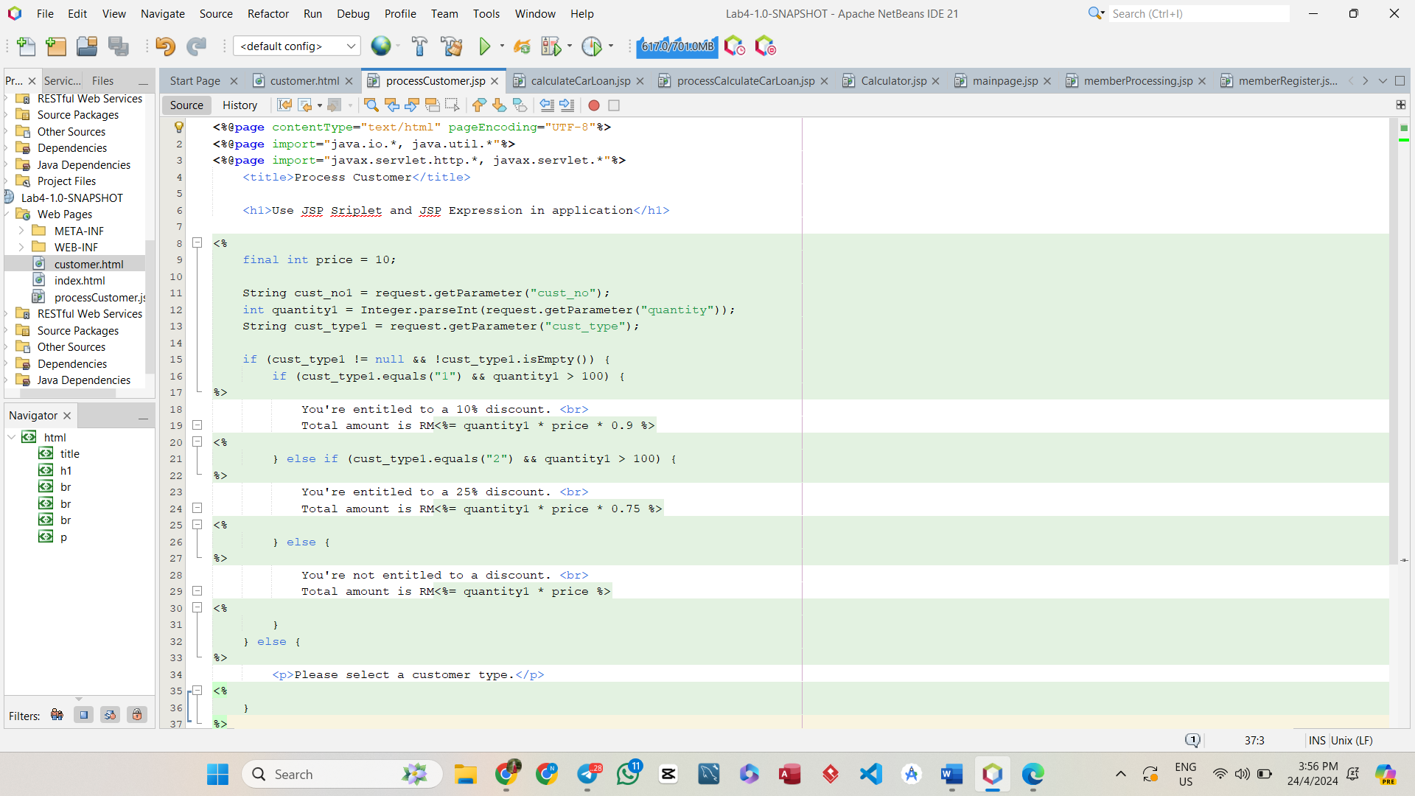

THE OUTPUT:

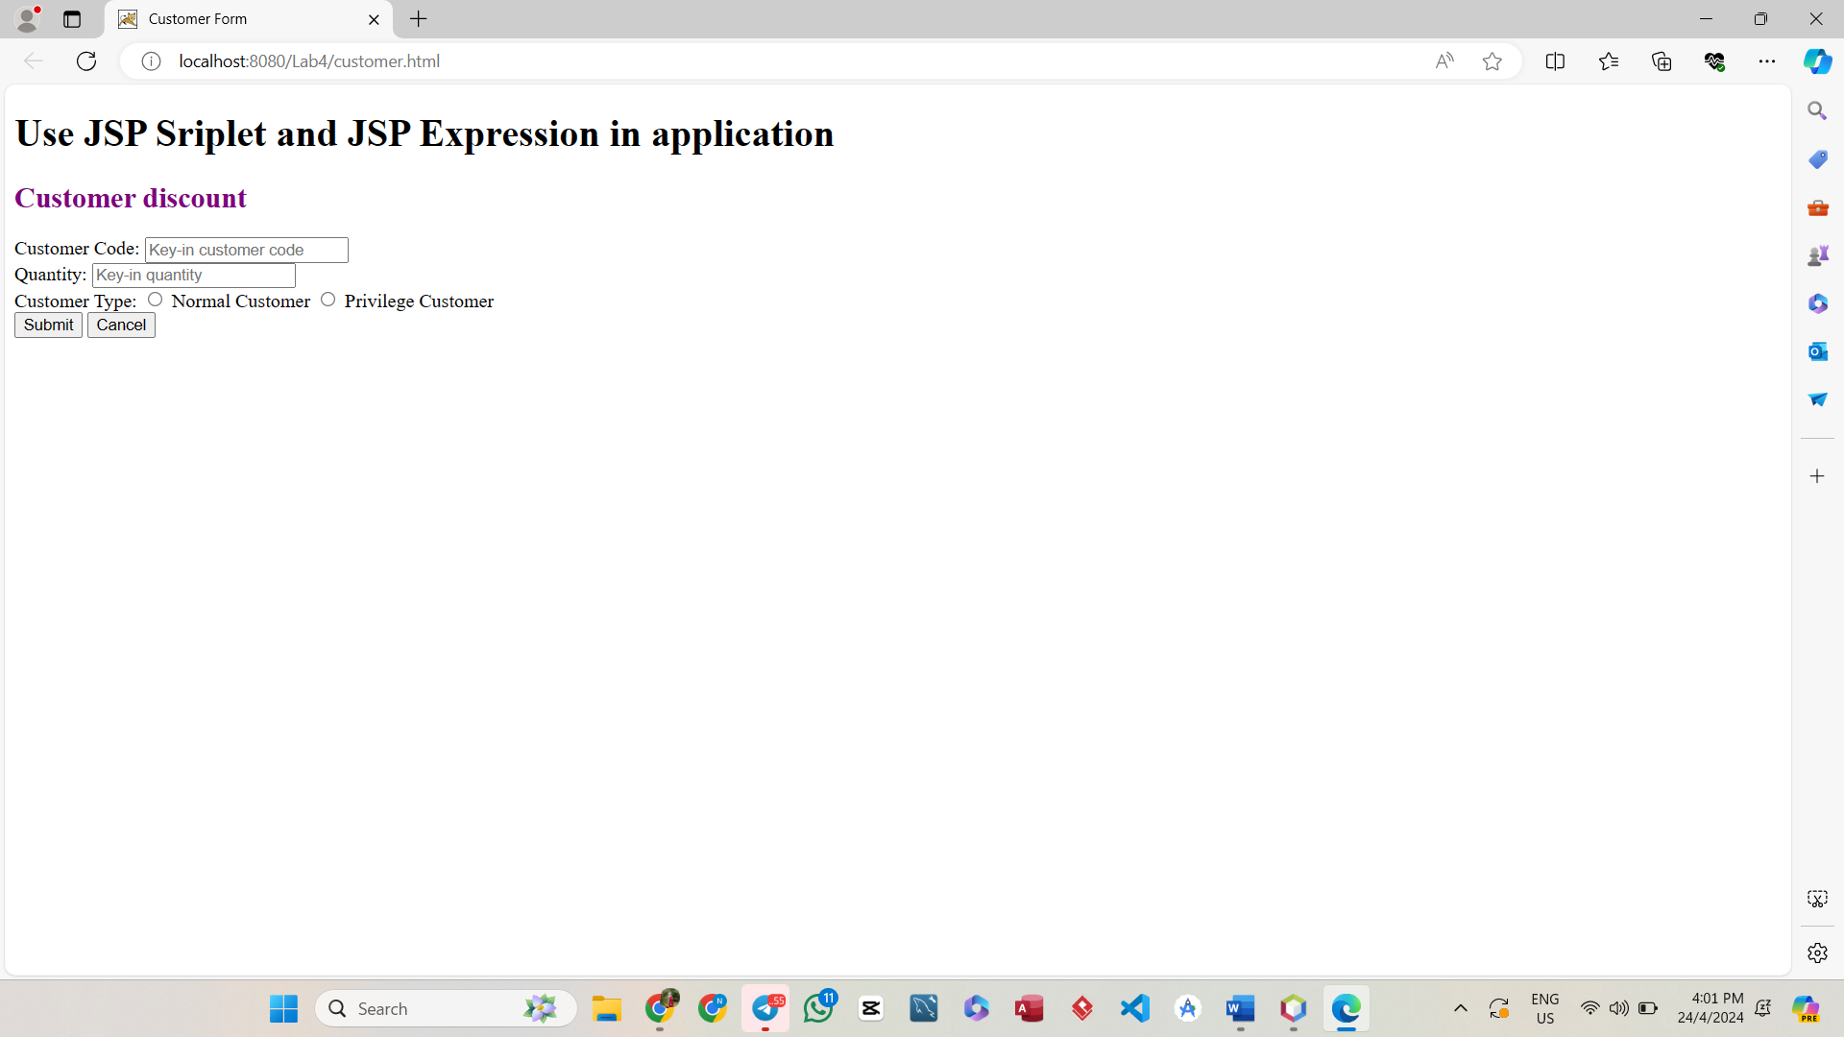

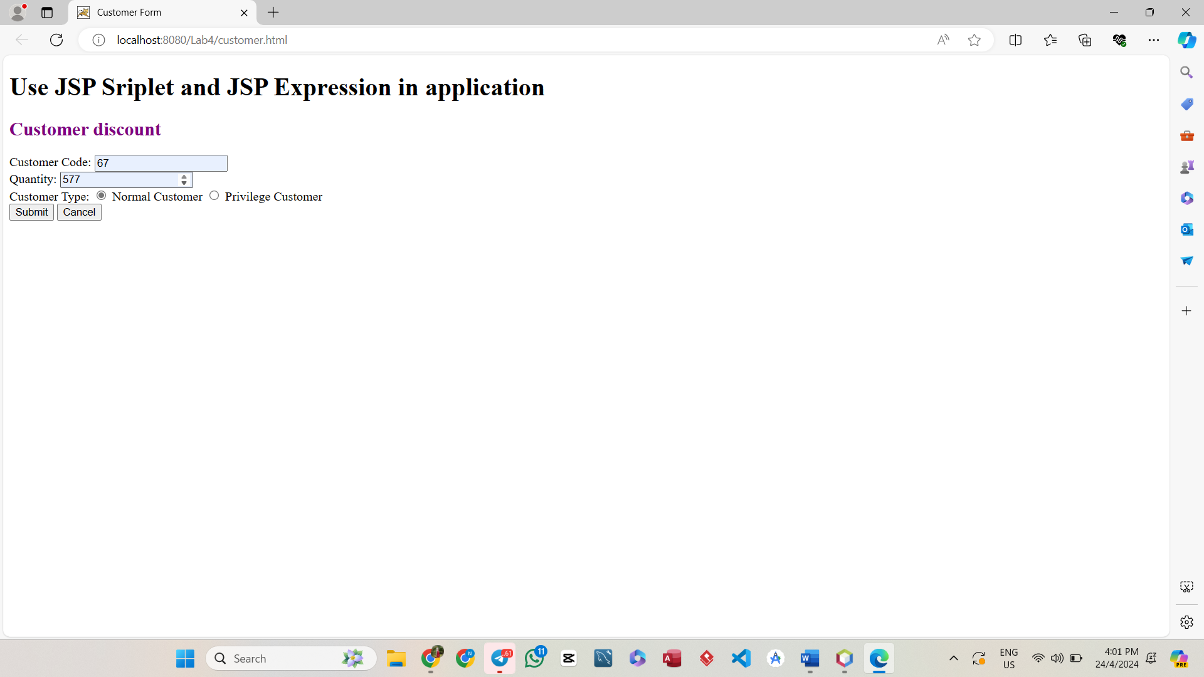

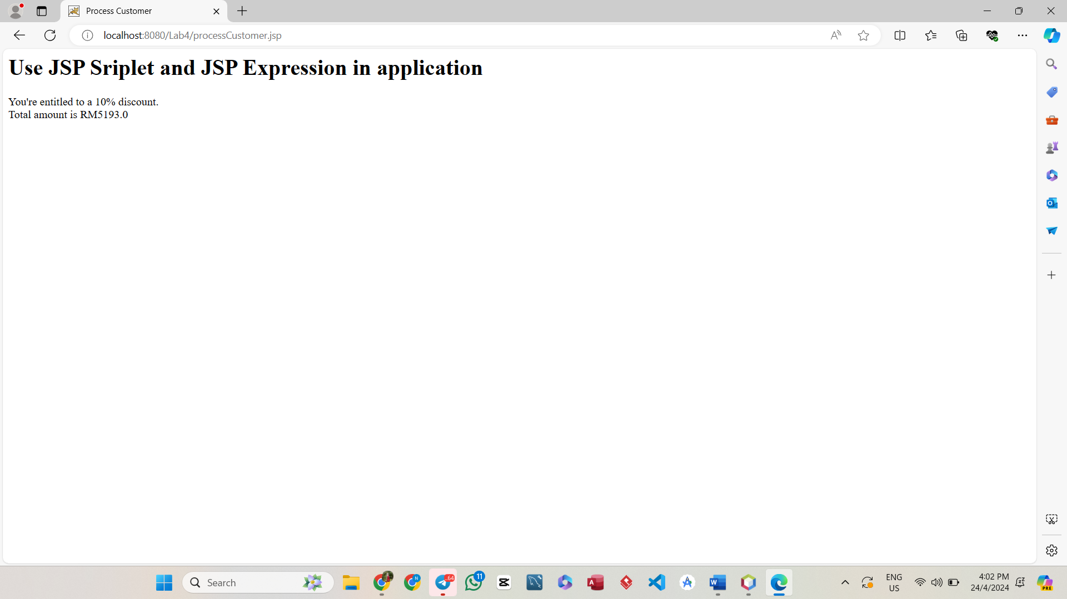

**Task 2: Using JSP (Scripting, Declaration and Expression)**

**Objective**

**:** Use JSP Declaration tag, JSP Scriptlet and JSP Expression

in application.

**Problem**

**Description**

**:** Create currency conversion page to Malaysia Ringgit into

US Dollar, Euro or Pound Sterling.

**Estimated time**

1 USD = RM3.92

1 Pound Sterling = RM5.96 1 Euro = RM4.47;

**:** 40 minutes

1. Choose Project *Lab3*.
2. Create a new HTML’s file.



1. Type file name as *currencyConversion.*
2. Prepare the following Graphical User Interface (GUI).

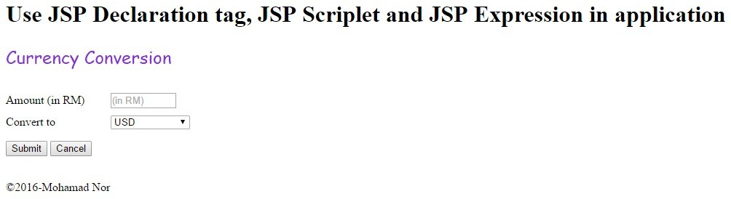

1. You must ensure the amount must be written as number.
2. The value for USD is “1”, Pound Sterling is “2” and Euro is “3”
3. Create a new file name known as *processCurrency.jsp*.
4. Define related variables, currency rate as a constant and method

*calculateRate(String code, int amount)* in JSP declaration tag as below.

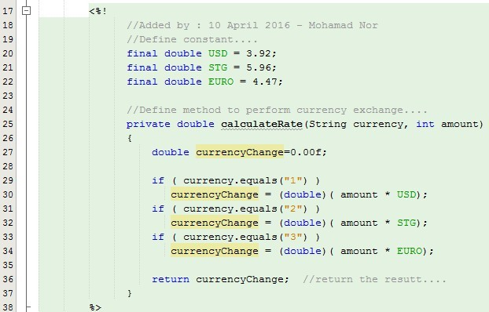

1. In your JSP scriptlet, retrieve the value for *Amount* and *Convert to* and assign to respective variables*.*
2. Call method *calculateRate(String code, int amount)* to perform currency conversion.
3. Finally, display the result using JSP Expression tag.
4. Compile *currencyConversion.html* and *processCurrency.jsp* file.
5. Run *currencyConversion.html.*
6. Enter the following information

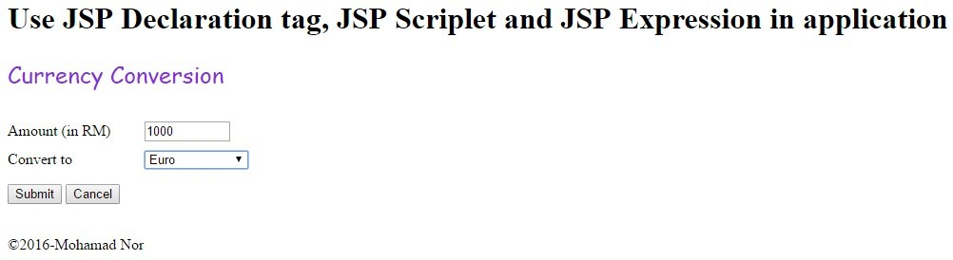

1. Output will appear in web browser (*Note: Amount must be in 2 decimal places*).

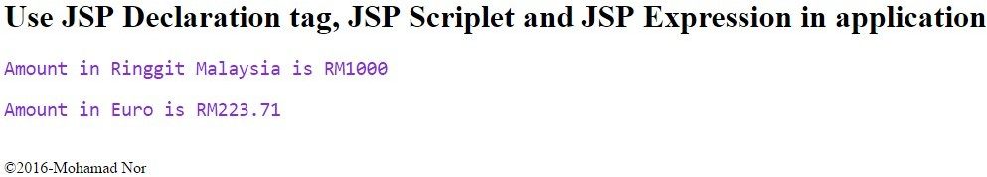

# Reflection

1. What have you learn from this exercise?

how to use Use JSP Declaration tag, JSP Scriptlet and JSP Expression in application.

THE CODE:

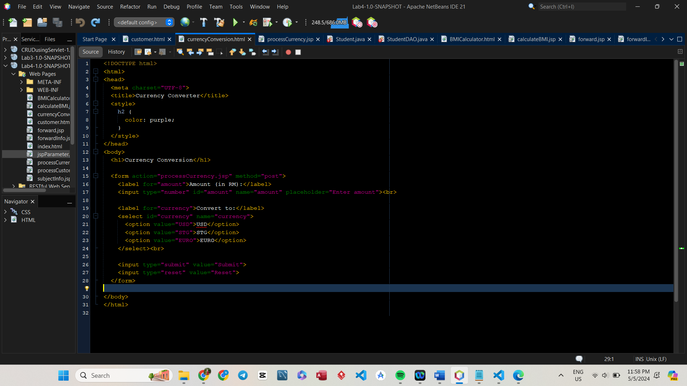

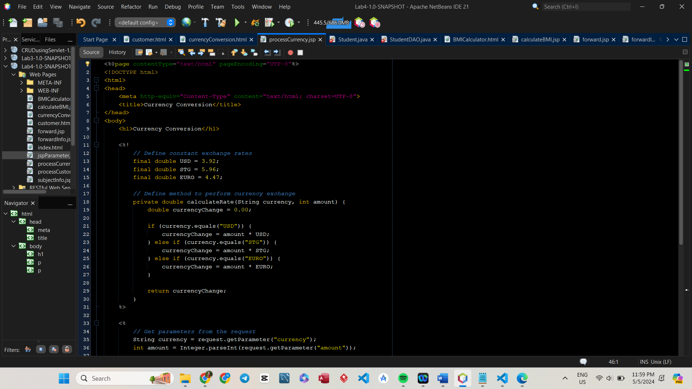

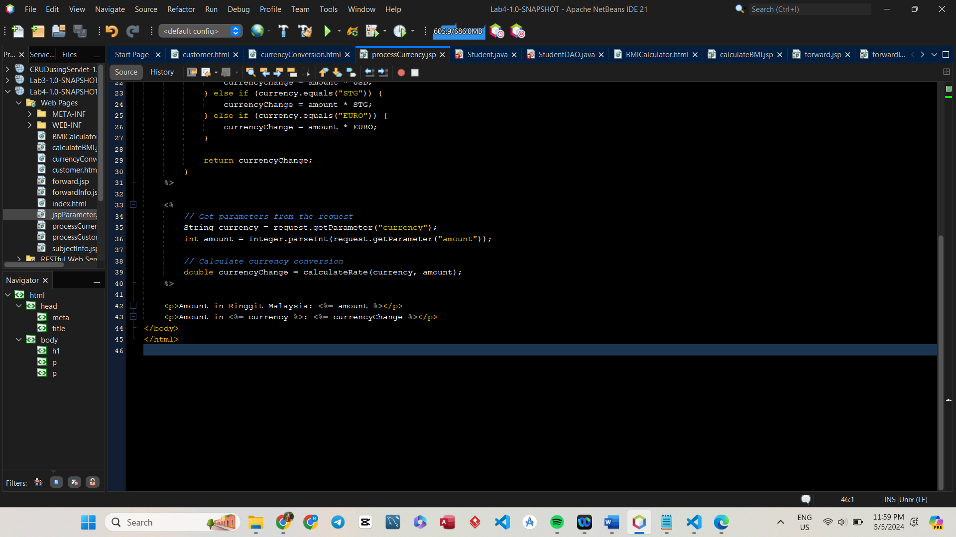

THE OUTPUT:

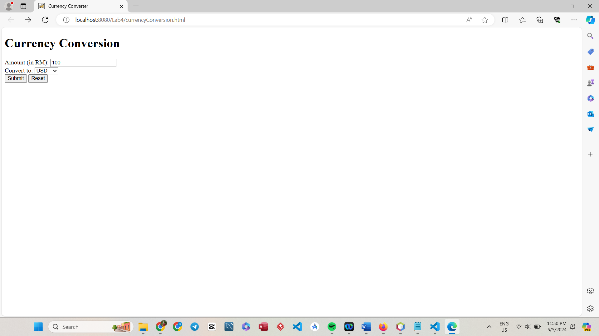

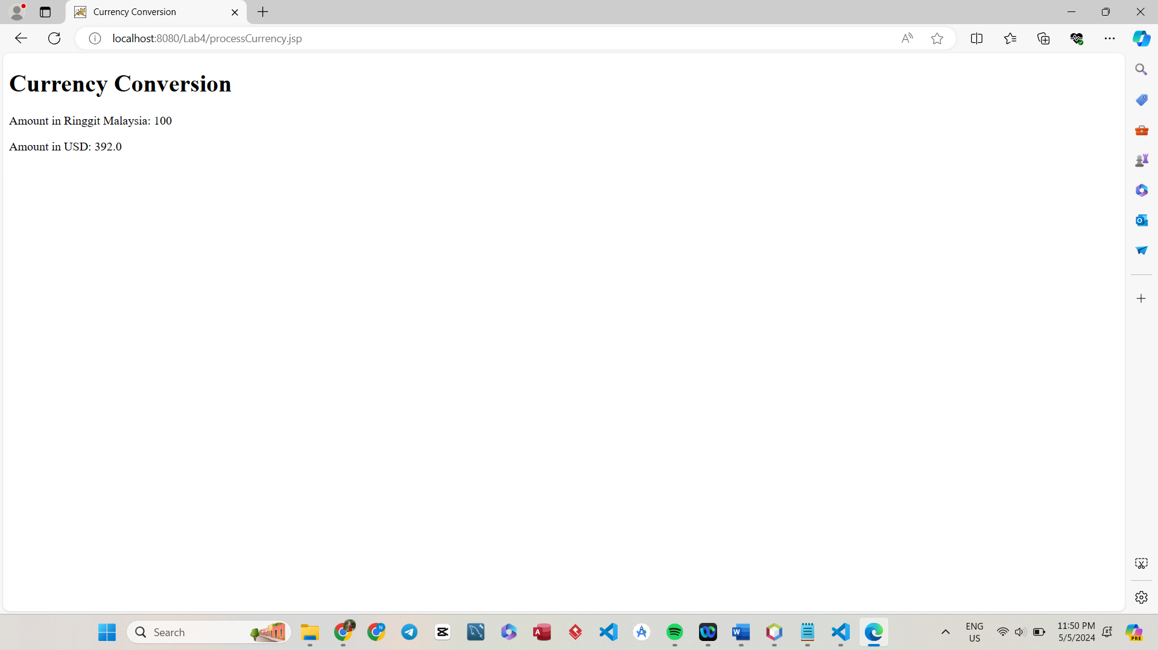



**Task 3: Using JSP Standard Action (Include and Param)**

**Objective**

**:** Using *<jsp:include>* and *<jsp:param>* to display

information on JSP page

**Problem Description**

**:** Display the course information.

**Estimated time**

**:** 20 minutes

1. Go to Project *Lab3*.
2. Create a new JSP’s file known as *jspParameter*.

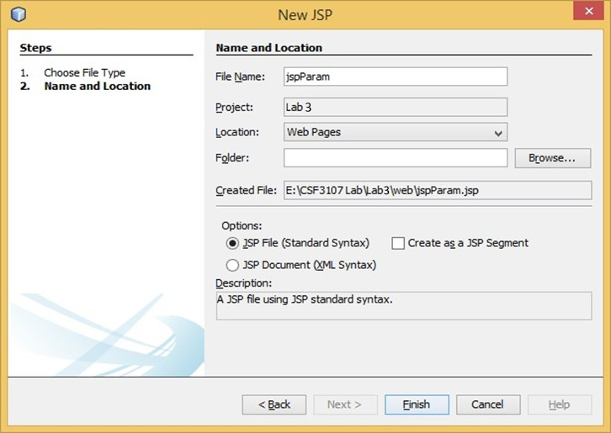

1. Prepare the following HTML’s syntax.

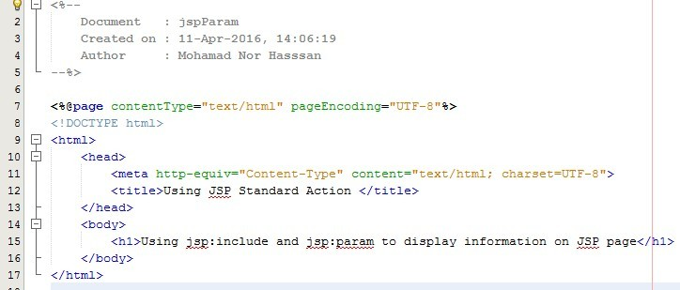

1. Add Java scriptlet.

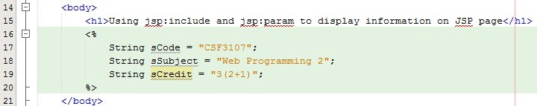

1. Add JSP Standard Action *<jsp:include>* to call *subjectInfo.jsp’s* page and

*<jsp:parameter>* to store the subject’s information .

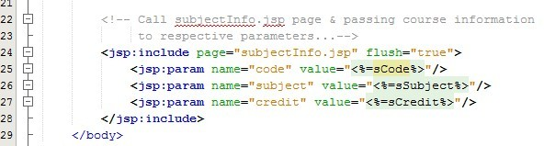

1. Save *jspParameter.jsp*’s file.
2. 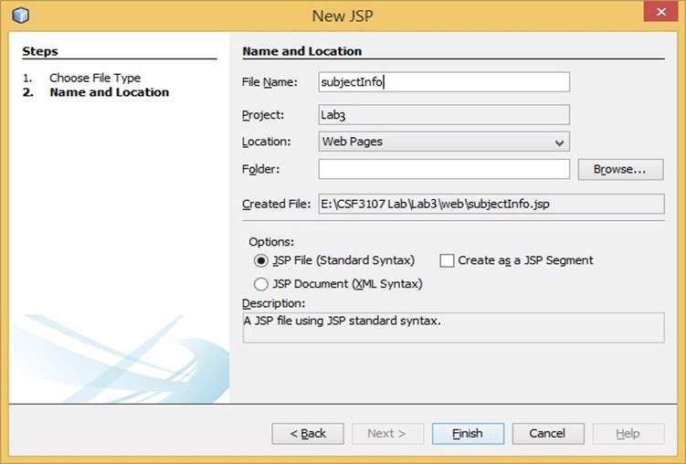Create another JSP’s file known as *subjectInfo*.
3. Write the following HTML’s syntax.

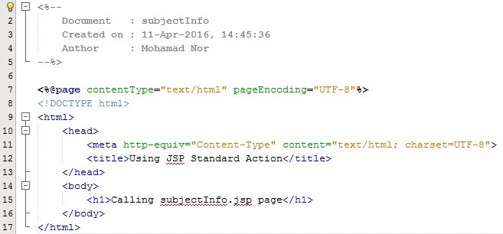

1. Add three (3) paragraphs and use JSP expression to retrieve and assign value to these paragraphs.

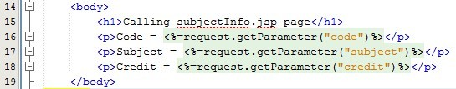

1. Save all files.
2. Compile and run *jspParameter.jsp*’s file.
3. Output will appear in web browser.

# Reflection

1. What you have learnt from this exercise?

How to use and to display information on JSP page

1. List **TWO (2)** other JSP Standard Action Tag.

jsp:useBean

jsp:setProperty

THE CODE:

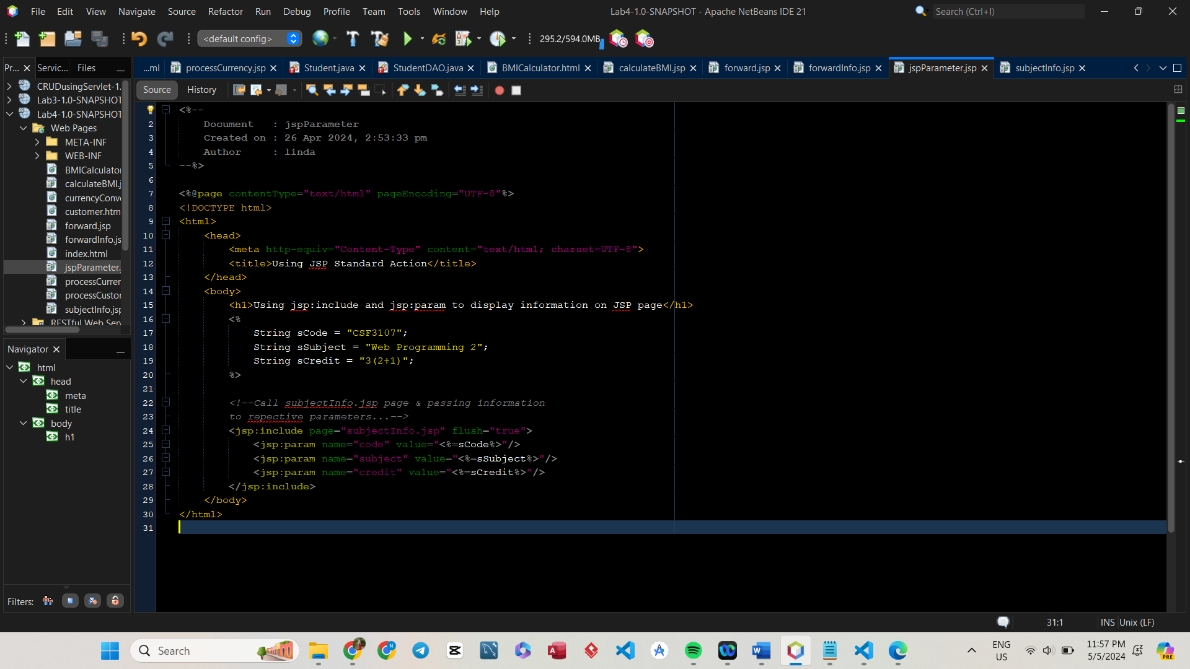

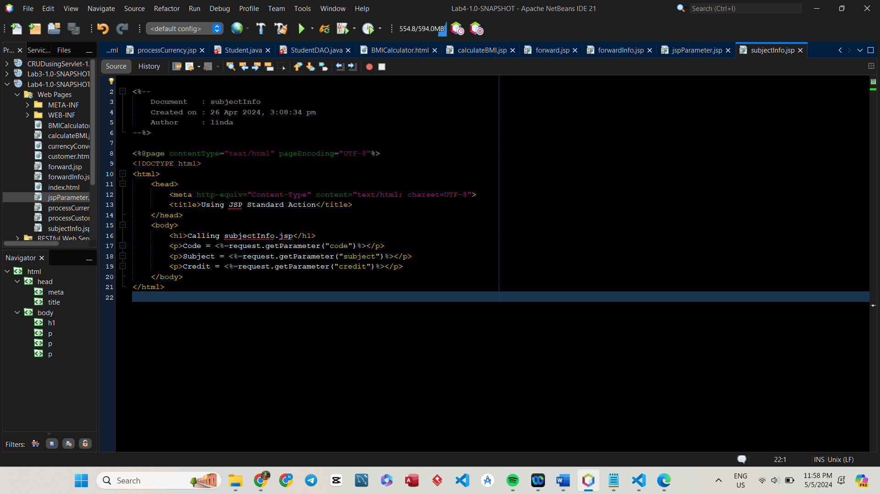

THE OUTPUT:

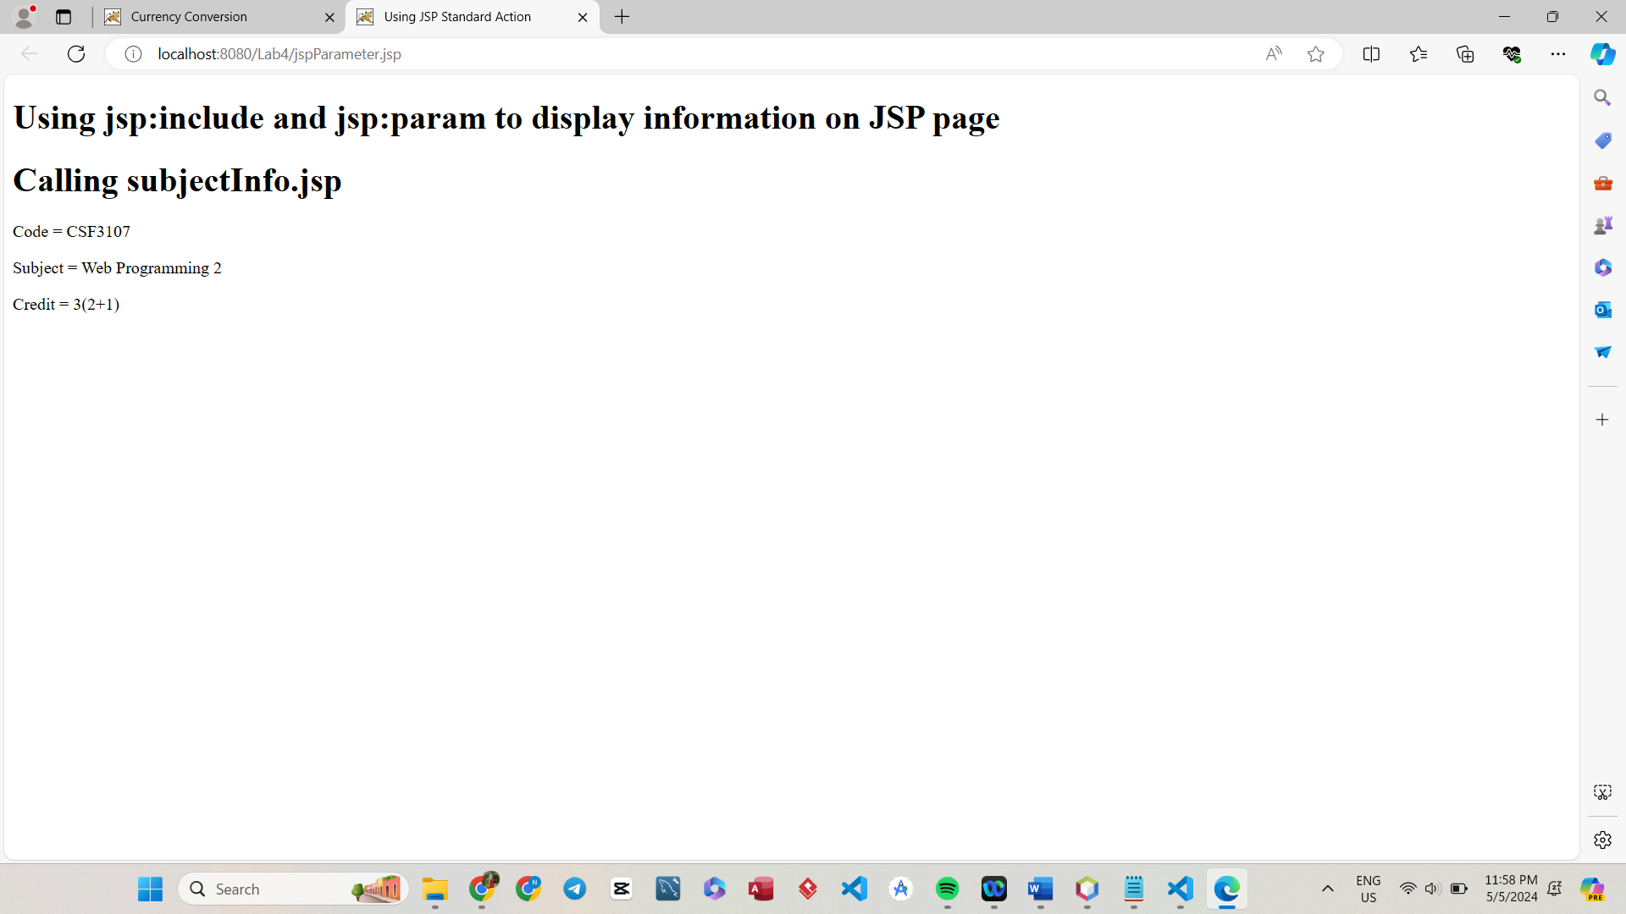

**Task 4: Using JSP Standard Action (Forward)**

**Objective**

**:** Using *<jsp: forward>* to display user information and

object on JSP page

**Problem**

**:** Display user information.

**Estimated time :** 20 minutes

1. Go to Project *Lab3*.
2. Create a new JSP’s file known as *forward*.

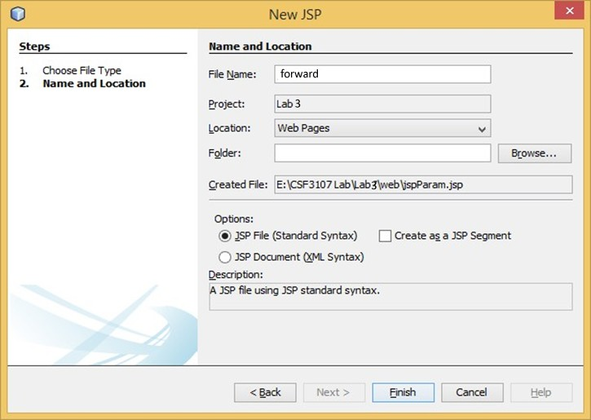

1. Prepare the following HTML’s syntax.

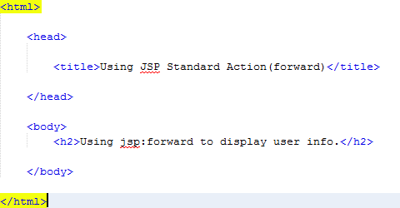

1. Add JSP Standard Action *<jsp:forward>* to call *forwardInfo.jsp’s* page and *<jsp:parameter>* to store the user’s information.

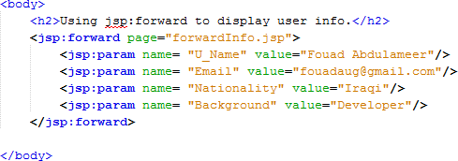

1. Save *forward.jsp*’s file.
2. 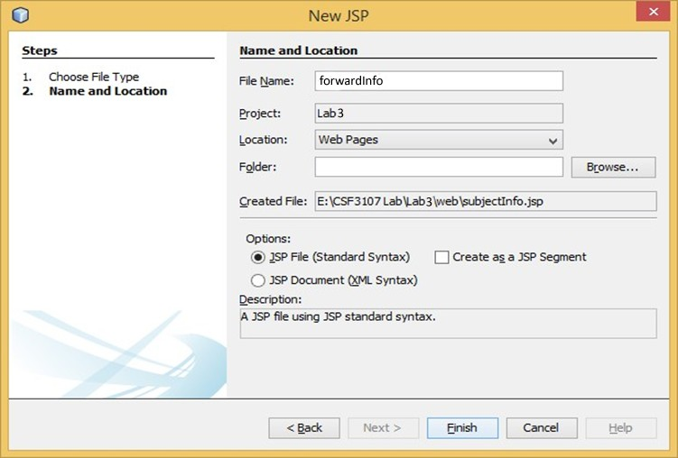Create another JSP’s file known as *forwardInfo*.
3. Write the following code.

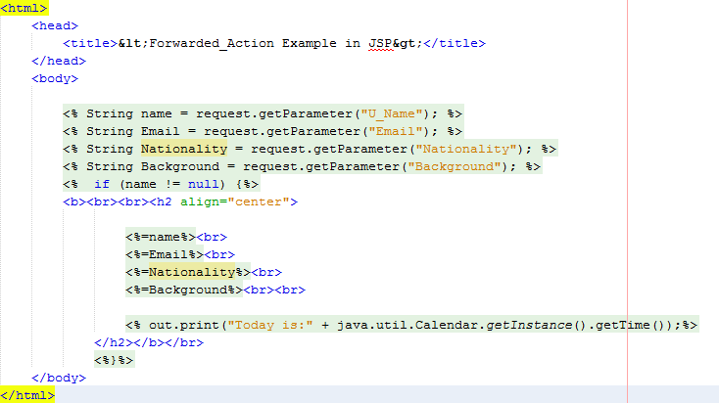

1. Save all files.
2. Compile and run *forward.jsp*’s file.
3. Output will appear in web browser.

# Reflection

1. What you have learnt from this exercise?

how to use to display user information and object on JSP page

1. List **TWO(2)** More JSP Standard Action Tag.

jsp:fallback

jsp:plugin

THE CODE:

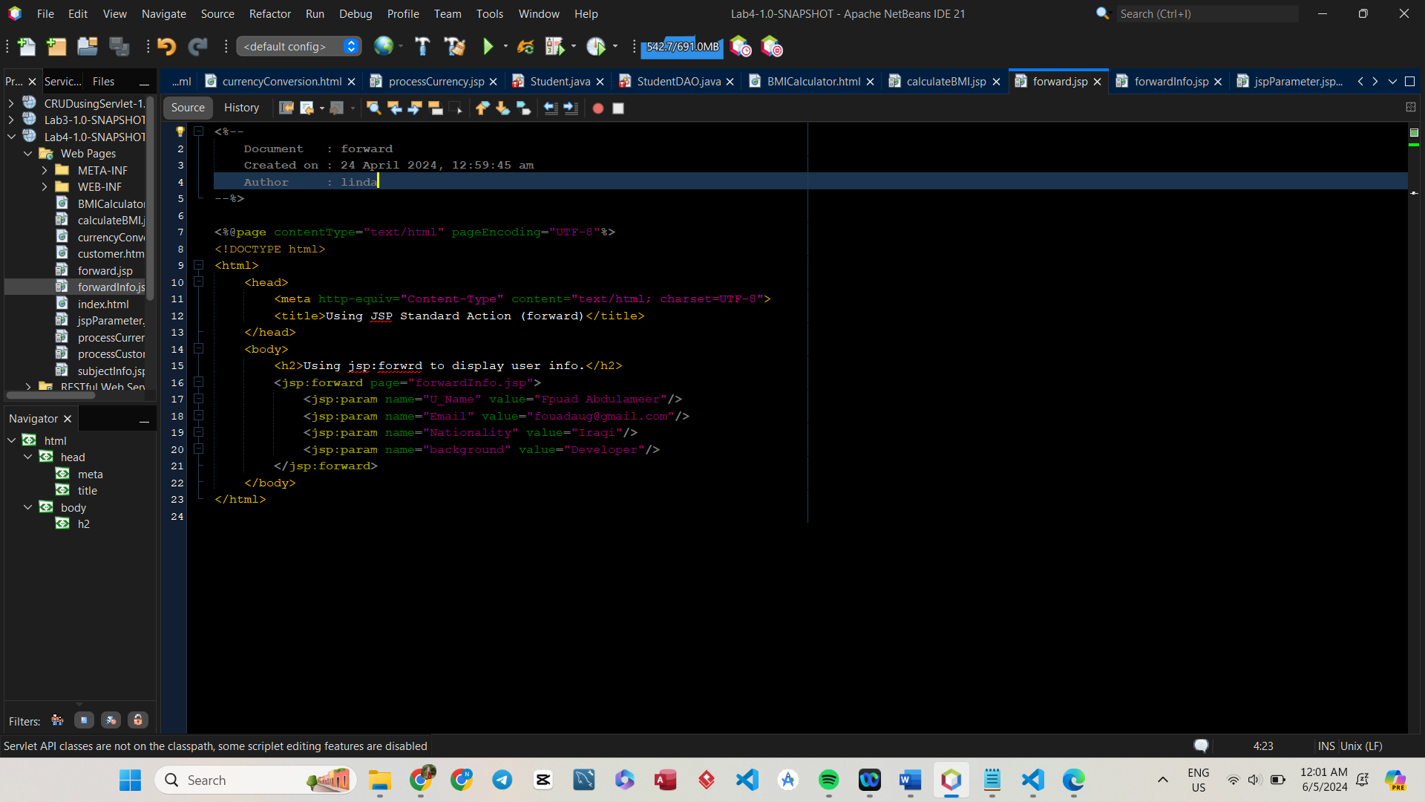

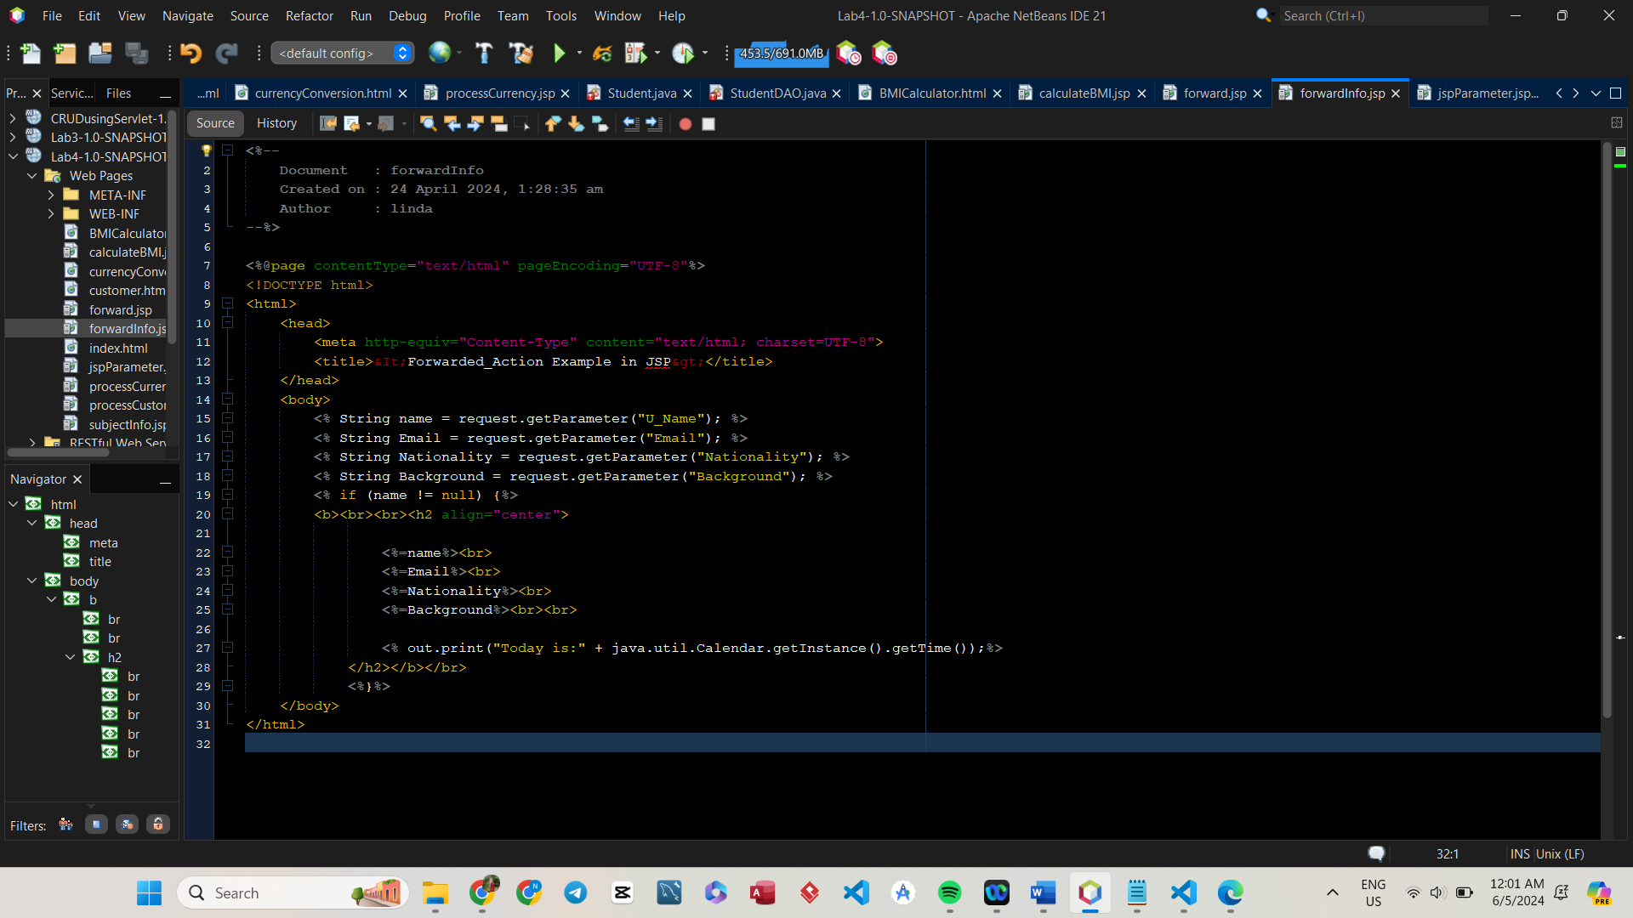

THE OUTPUT:

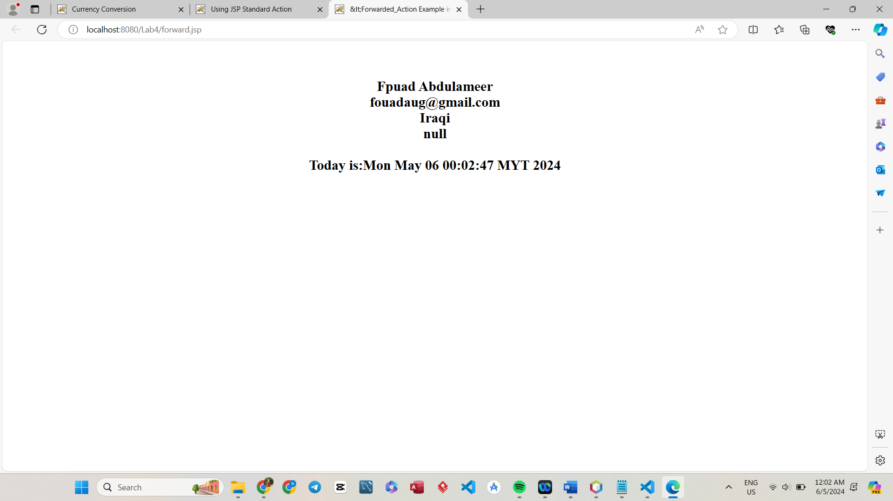



**Task 5: Use Java Scriptlet To Construct Business Logic**

**Objective :** Use Java Scriplet to perform business logic.

# Problem Description

**:** Create a simple web based form to calculate the insurance quotation.

Coverage type – Third Party (value as “1”)

Comprehensive ((value as “2”) Formula for insurance comprehensive

NCD = 55%, 1.8% x market price NCD = 35%, 2.4% x market price NCD = 25%, 3.0% x market price NCD = 10%, 3.8% x market price

Formula for third party

NCD = 55%, 1.2% x market price NCD = 35%, 1.8% x market price NCD = 25%, 2.5% x market price NCD = 10%, 3.3% x marketprice

**Estimated time :** 50 minutes

1. Go to project *Lab3*.
2. Create a new JSP’s file as *insuranceQuotation*.
3. Prepare the following Graphical User Interface (GUI).

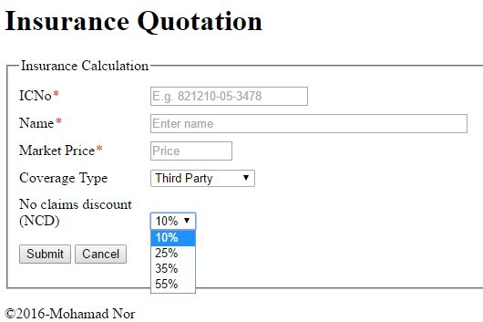

1. You need to ensure all front-end validation take place.
2. Creating another JSP’s file known as *processInsuranceQuo.jsp*.
3. Use Java Scriplet to perform the business logic for the application in page *processInsuranceQuo.jsp*.
4. Final insurance amount must be added with 6% GST.
5. Save your file.
6. Right click *insuranceQuotation.jsp* and compile the program.
7. Test your application by key-in the following information.

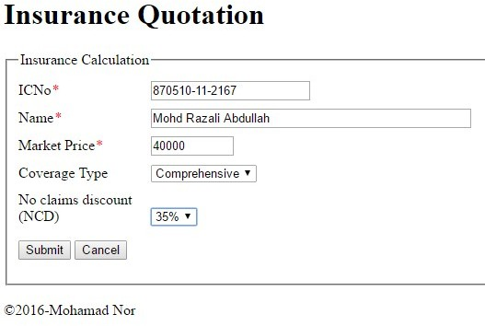

1. You should get the following output.

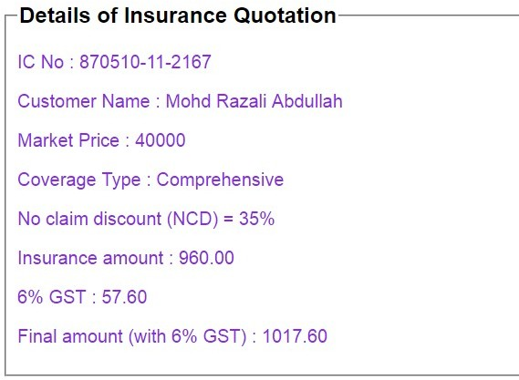

# Reflection

1. What you have learnt from this exercise?

how to use Java Scriplet to perform business logic.

1. List all Java features you used in Java Scriptlet.

In the Java Server Pages (JSP) scriptlet, the following Java features are used:

1. Declaration: `<%! ... %>` for variables and methods.

2. Conditional Statements: `if-else`.

3. Variable Declaration & Assignment.

4. Method Declaration & Invocation.

5. Request Handling: `request.getParameter()`.

6. Type Casting: `Integer.parseInt()`.

7. Arithmetic Operations: Multiplication.

8. Constants: Defined using `final`.

THE CODE:

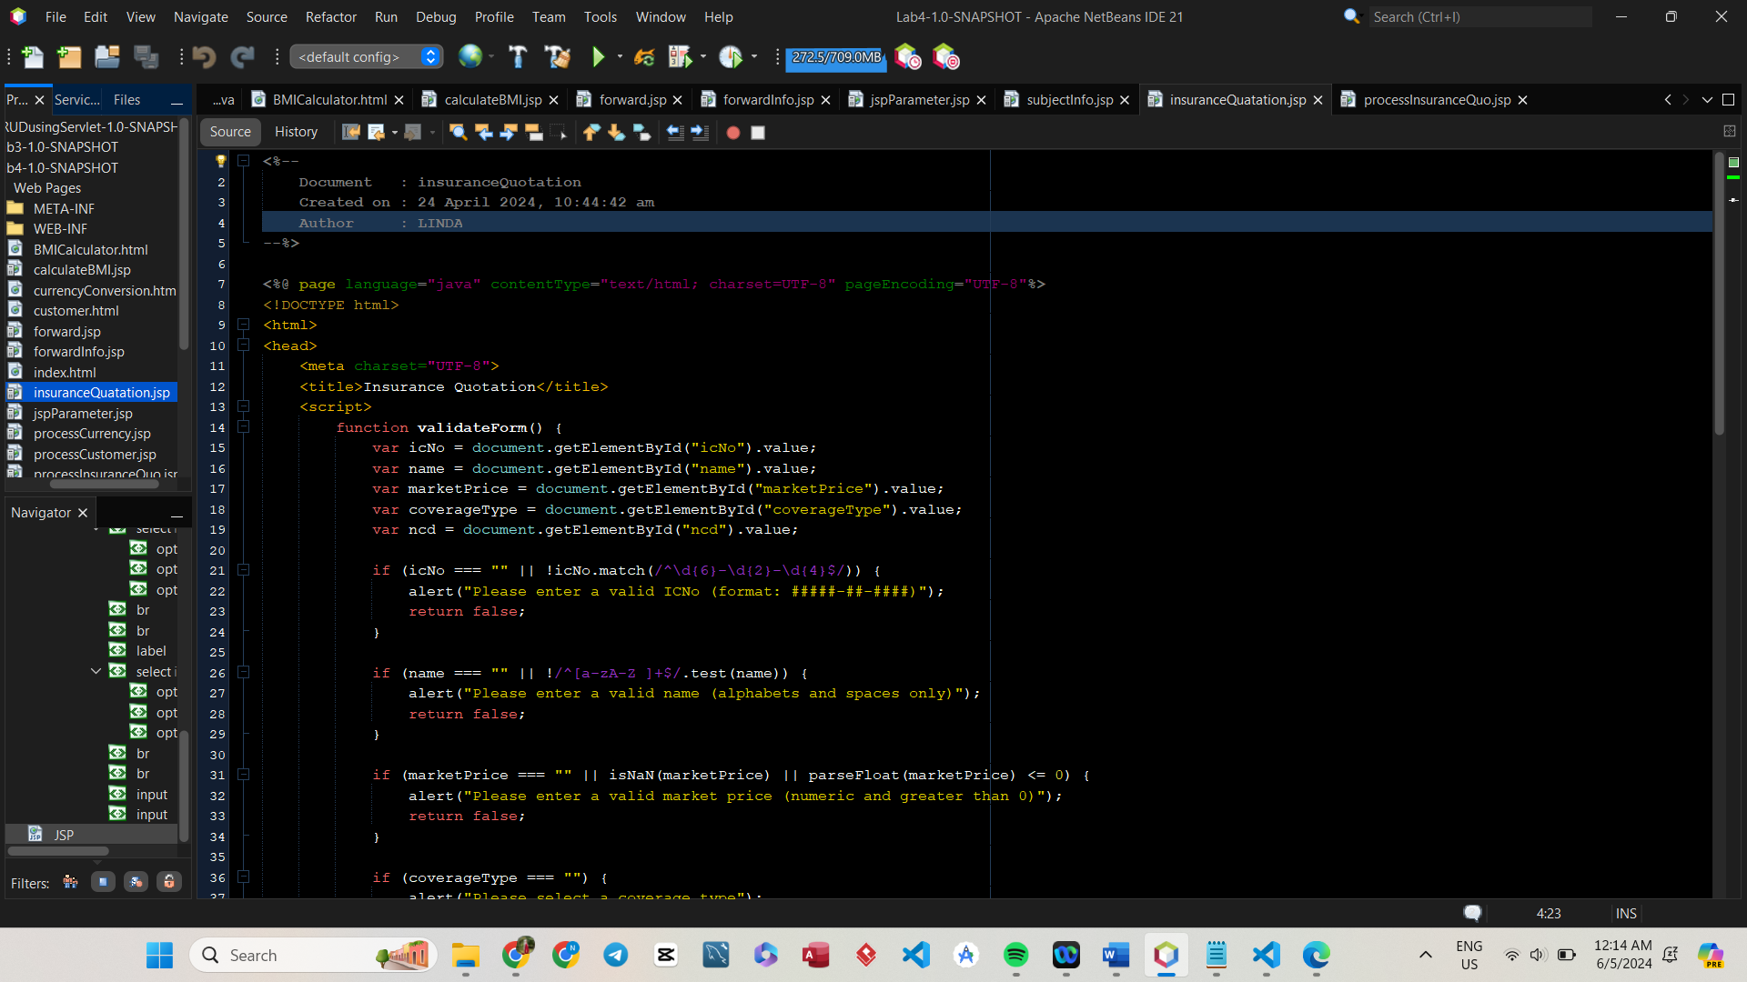

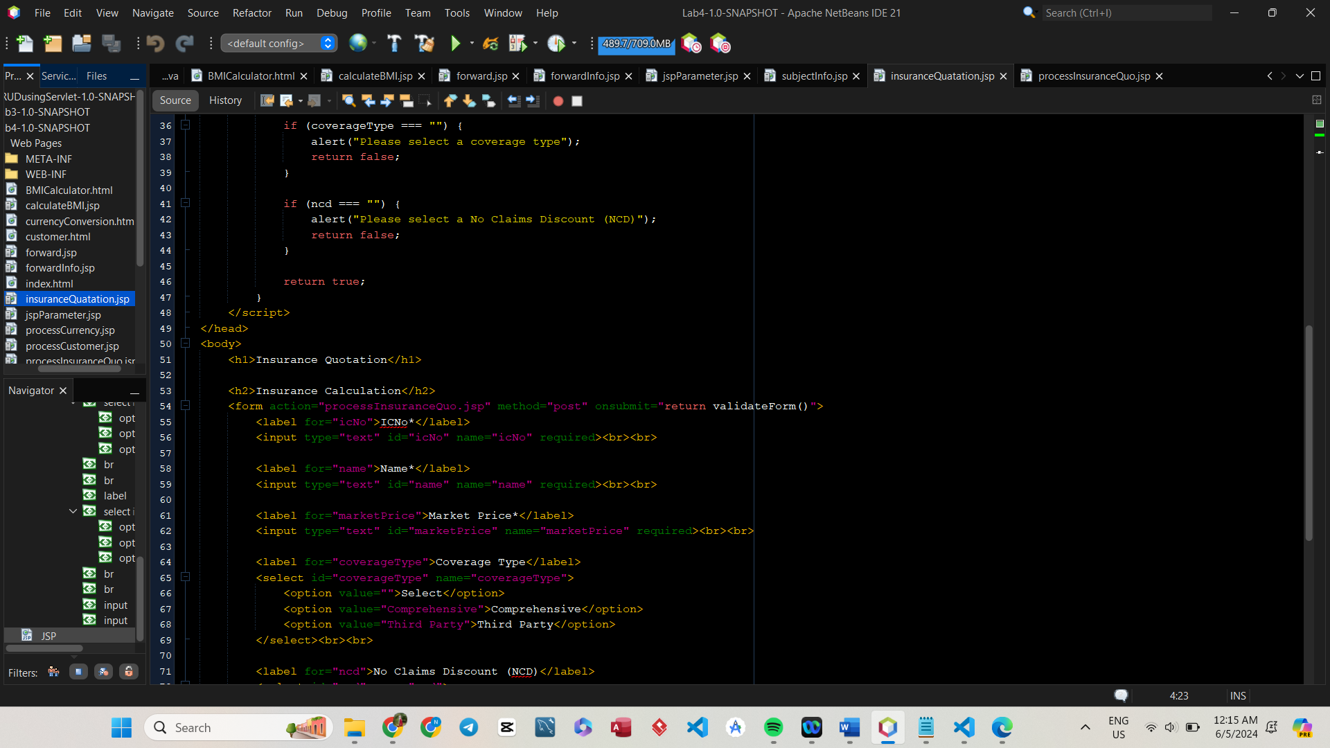

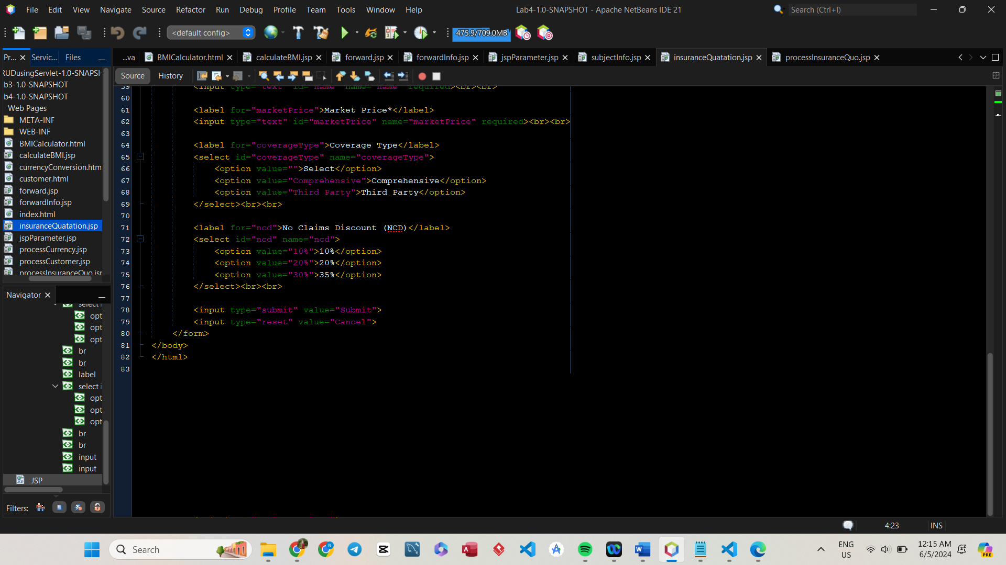

THE OUTPUT:

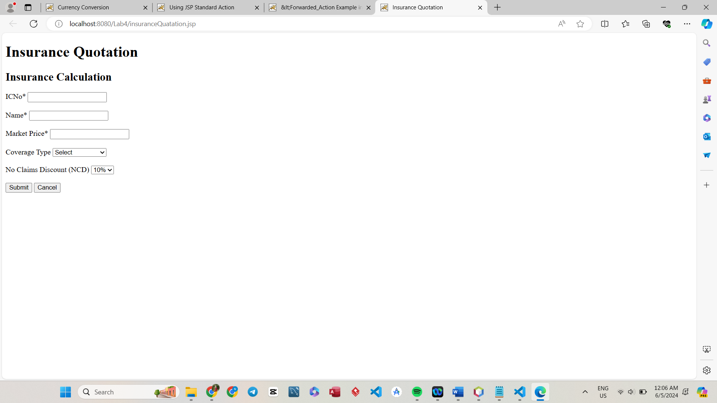

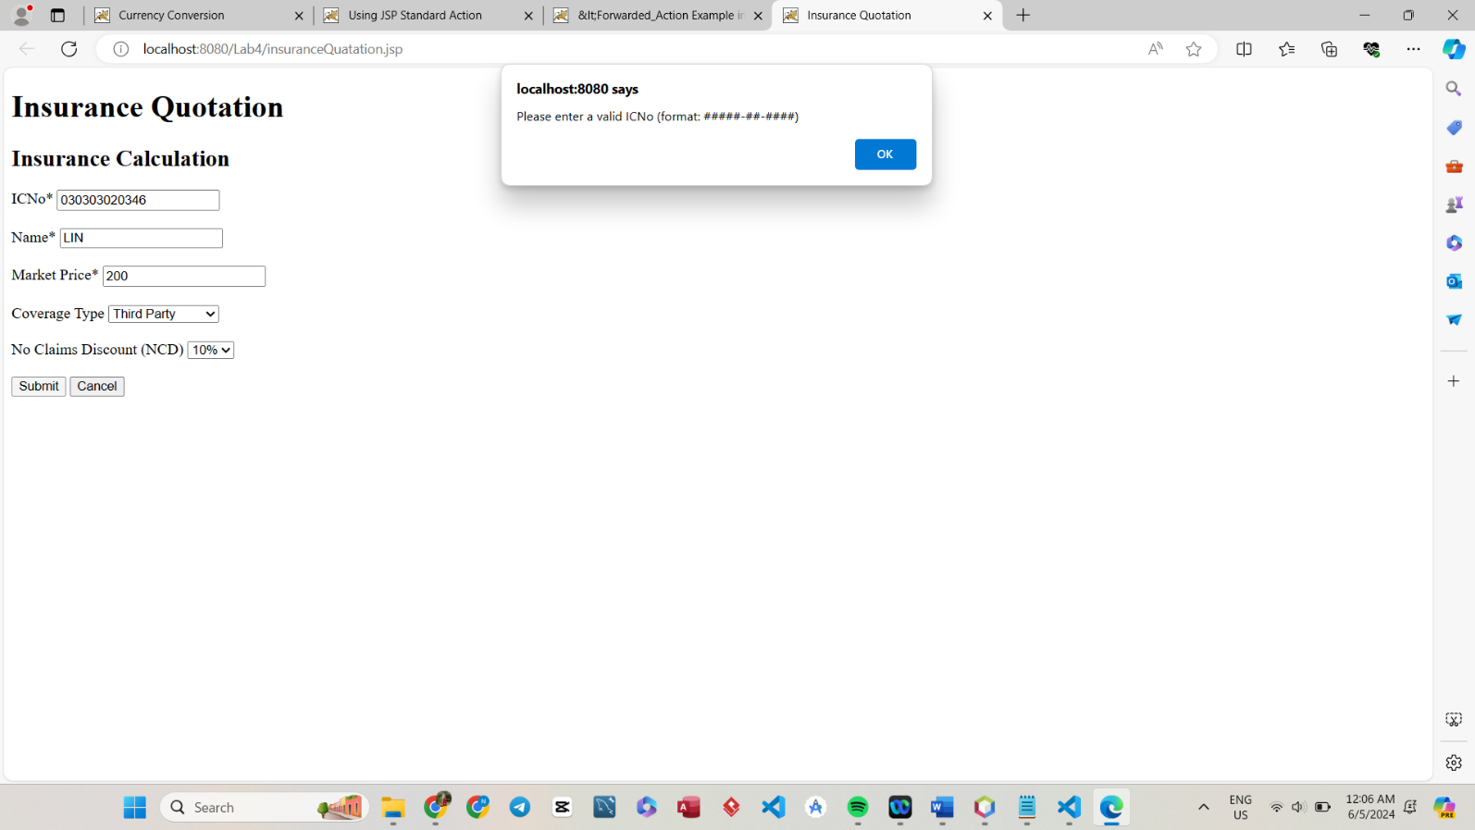

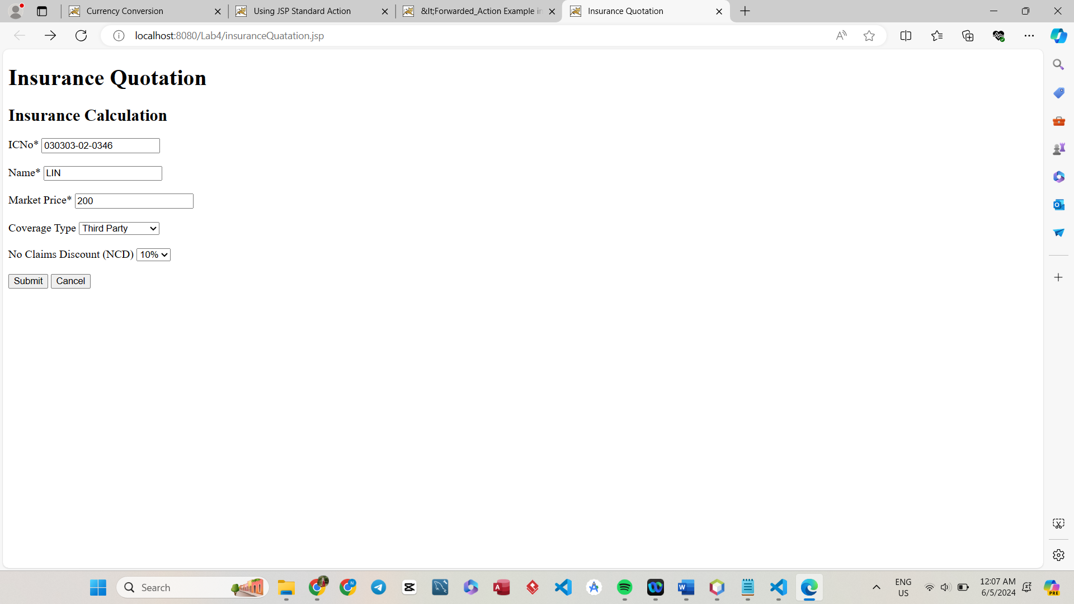

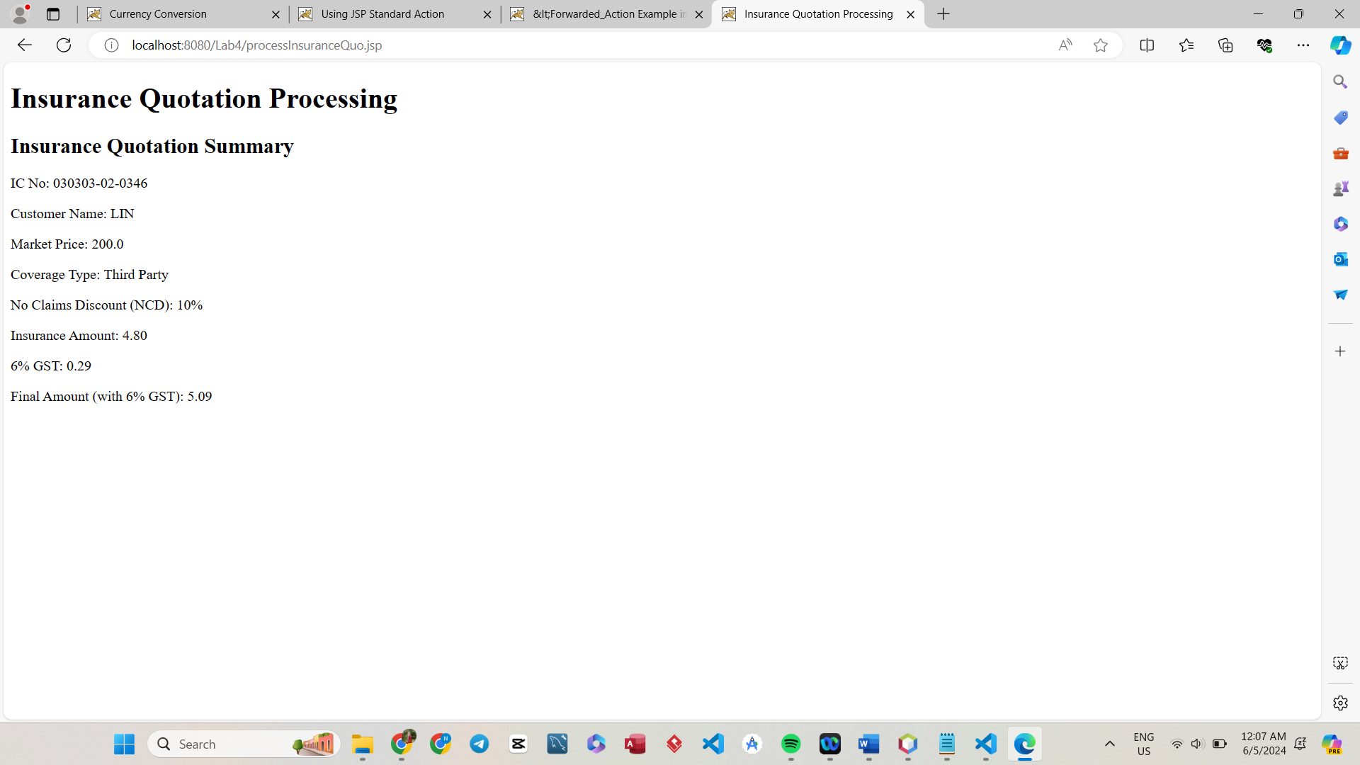

# Exercise

1. Write a simple application to calculate and display a person’s body mass index (BMI). The BMI is often used to determine whether a person is overweight or underweight for his or her height. A person’s BMI is calculated with the following formula:

# BMI = weight /height2

where weight is measured in kilogram and height is measured in meter. User should enter his or her weight and height and then display the user’s BMI.

The program should also display a message indicating whether the person has optimal weight, is underweight, or is overweight. A person’s weight is considered to be optimal if his or her BMI is between 18.5 and 25. If the BMI is less than 18.5, the person is considered to be underweight. If the BMI value is greater than 25, the person is considered to be overweight.

THE CODE:

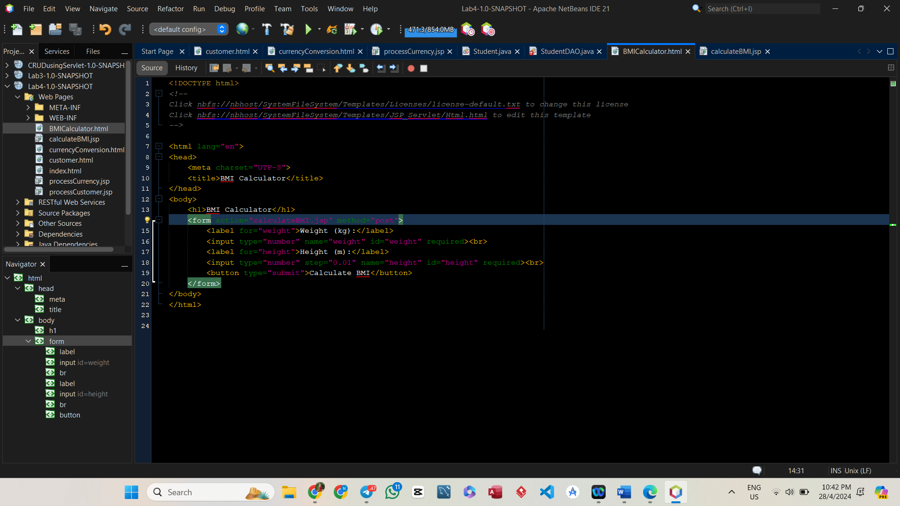

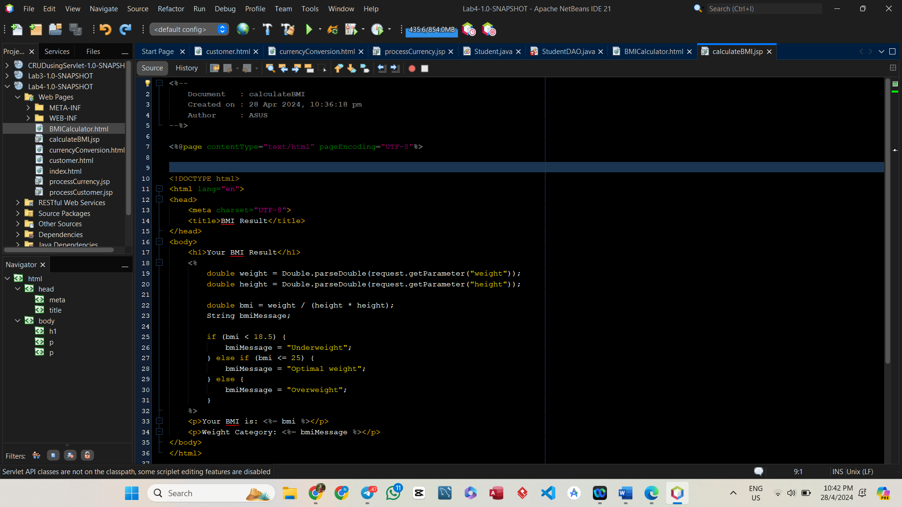

THE OUTPUT:

